Label the diagram below with the four main layers you listed in question 6.
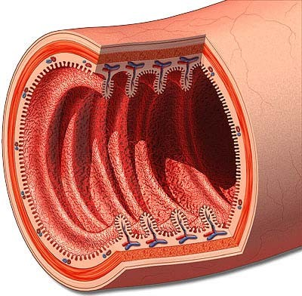

- Label the vessels you listed in question 13 in the diagram below.
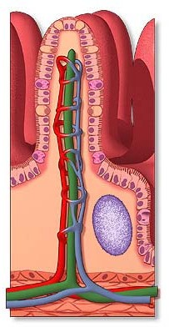

- Label the three sheets of muscle in the stomach’s muscularis externa in the diagram below.
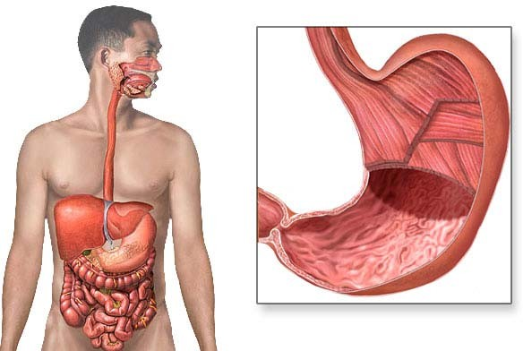

- Label two of the modifications of the intestine to increase surface area in the diagram below.
